------------------------------------------------------------------------------------------------------------------------------------------

_____________________________________________________________________________________

*Assignment # 2*

**ASSIGNMENT TOPICS:**

* PAN
* LAN
* MAN
* WAN
* CAN

Department: **Computer Science**

Course Title:

**Fundamental of ICT**

Course Code: **CS-100**

Submitted to: **Dr. Sir Abdullah Khan**

Submitted by: **Muhammad (391855)**

1st Semester,

Session **2021-2025**

**Date of Submission: 28/March/2022**

_____________________________________________________________________________________

**INTRODUCTION:**

PAN, LAN, MAN, WAN and CAN are the types of computer network. Networking of PCs has been developed for all levels, from local to international, in diverse sectors of society. Examples are networks used by government organizations for rapid retrieval of information from database at central locations. Networks are used by banks and retail merchants for the transfer of funds or credit verification. PCs used corporate offices to get information of activities at its branch offices and etc.

The main types of computer networks are given and defined below:

**PAN:**

It stands for **Personal Area Network**. This network is the simplest of all the networks. This provides data exchange between individual’s workspace i.e. in between personal computers, smartphones, and other digital sharing devices. This can be done via wired media or wireless (Bluetooth, infrared, ZigBee and many more). However for wireless transmission of data packets, this supports a very small range ranging from few centimeters to few meters.

**DIAGRAM:**

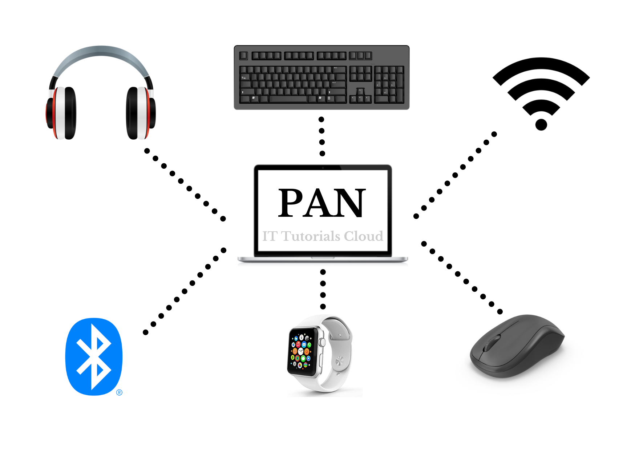

**LAN:**

All networks need some system for interconnection. In some LANs, a shared network cable connects the nodes. Low-cost LANs are connected with twisted wire pairs, but many LANs use coaxial cable or fiber optic cable, which are both more expensive and faster. Some LANs are wireless, using infrared of radio wave transmissions instead of cables. Wireless networks are easy to set up and reconfigure, since there are no cabin cables to connect the devices, but they have slower transmission rates and limit the distance between nodes.

**DIAGRAM:**

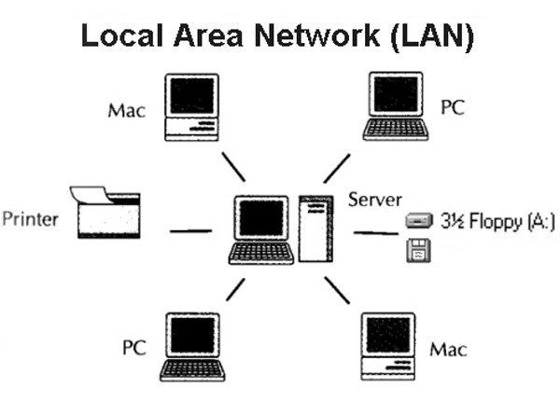

**MAN:**

It stands for **Metropolitan Area Network**. A metropolitan area network (MAN) is a communications network covering a geographical area the size of a city. The purpose of a MAN is often to bypass local telephone companies when accessing long distance services. Mobile phones (Cellular) systems are often MANs. A MAN is simply a bigger (modified) version of a LAN that precisely uses similar technology. It is developed in order to extend over a very larger area such as an entire city.

**DIAGRAM:**

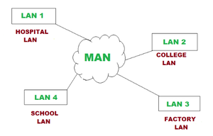

**WAN:**

It stands for **Wide Area Network**. A wide area network is a network of geographically distant computers terminals. In practice, a personal computer sending data to some remote area is probably sending it to the mainframe or minicomputer. Since the larger computers are designed to be accessed by terminals, a PC can communicate with larger computers only if the PC imitates to be a terminal this is mid possible by using terminal emulation software on the PCs. The larger computers then consider the PC or workstation as just another input/output device i.e. a terminal. The larger computer to which the terminal or PC is attached is called the host computer. If a PC is being used as a terminal, file transfer software permits users to download data files from the host or upload data files to it from another computer and to send it to the computer of the user who requested the file. To upload a file, a host. To download a file means to retrieve it from user sends a file to another computer. All the communication across the WAN is made possible via ordinary telephone lines, microwave or satellite links, of the typically, la WAN is two or more LANs connected together across a wide geographical area using the connectivity mentioned above. The Internet went the ultimate WAN because it connects many thousands of computers and LANs around the world, ultimately making it as WWW (World Wide Web).

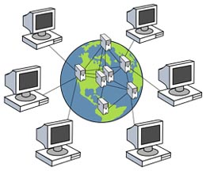

**CAN:**

It stands for Campus Area network. A campus network as the name represents, is simply a local area system (LAN serving an organization, government agency, university, or comparable organization). The users in a campus area network are dispersed more commonly (in a sense that is geographical) than in a single LAN, but they are usually not as spread as they might be in a wide area network (WAN). A campus area system (CAN) is simply a network of multiple interconnected local area sites (LAN) in a very restricted area that is geographical. A CAN is smaller than the region that is with WAN or even a metropolitan area system (MAN). A CAN is further known as the corporate area network (CAN). It is much cost-effective and multidepartment accessible, further it will be single shared data rate.

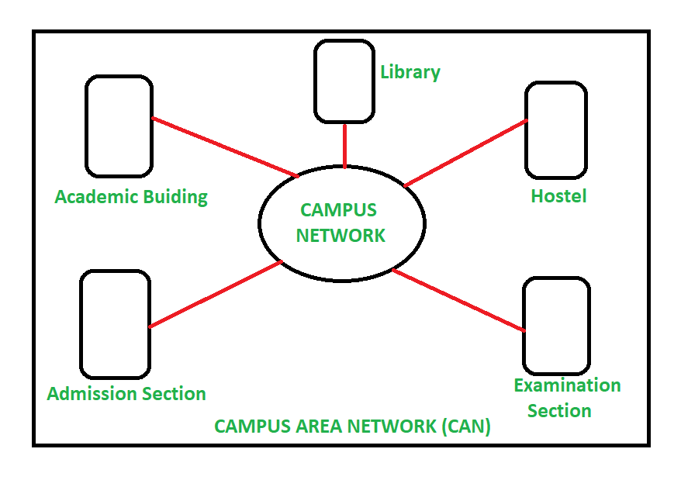

“The computer was born to solve problems that did not exist before.”

-**Bill Gates**

**THE END**